INFLUENCE OF HUMIDITY AND PRESSURE ON SEPARATION OF ETHYLENE/ ETHANE MIXTURES WITH SULFOCATIONITE MEMBRANES
¹N.A.Zhilyaeva, ¹E.Yu.Mironova, ¹M.M.Ermilova, ¹N.V.Orekhova, ²N.V.Shevlyakova, ²M.G.Dyakova, ²V.A.Tverskoy, ^{1,3}A.B.Yaroslavtsev
¹ A.V.Topchiev Institute of Petrochemical Synthesis, RAS, Moscow, Russia, E-Mail: zhilyaeva@ips.ac.ru
² Lomonosov Moscow State University of Fine Chemical Technologies, Moscow, Russia, E-Mail: tverskoy@mitht.ru
³ Kurnakov Institute of General and Inorganic Chemistry, RAS, Moscow, Russia, E-Mail: yaroslav@igic.ras.ru

Introduction
One of the problems of pure light olefins preparation is the separation of saturated and unsaturated hydrocarbons mixtures. Industrially, this separation is carried out by cryogenic distillation, which is highly energy-intensive. The membrane separation has some advantages in comparison with distillation and adsorption methods due to their low energy consumption, moderate cost and compact design. However, ethylene/ethane separation with the use of conventional membranes has difficulties, being the result of the similar structure and sizes of their molecules. This problem can be solved with the use of membranes of "facilitated" transport due to selective formation of ethylene complexes with carrier. In our opinion the most promising can be ion exchange membranes in H⁺ or Ag⁺ form. Membranes from PE– graft– sulfonated polystyrene (PS) were chosen because of the possibility to change the content of carrier concentration and water uptake by varying the PS grafting degree [1]. The use of Ag⁺ form of investigated membranes showed their effectiveness for ethylene/ethane separation, the separation factor achieves high values up to 120. But these membranes lost gradually the selectivity owing to Ag⁺ ions, which are easily reduced under exposure to light to Ag nanoparticles. The same membranes in H⁺ form appeared to be more stable.
The aim of this work was to study influence of humidity and pressure on a separation process ethylene/ethane mixtures on polymeric sulfocationite membranes.
Experiments
Ion-exchange membranes based on polyethylene (PE), grafted with PS were prepared by the post-radiation graft polymerization of styrene on low-density PE film and the subsequent sulfonation of the grafted PS [1]. The permeability (P) of the polymer films was studied in a stainless steel permeation flow cell partitioned into two non-interconnected compartment by a membrane [2]. One of the compartments was fed with the individual gases (ethane and ethylene) or mixtures of ethane and ethylene in various ratios, and the carrier gas (helium) was passed through the other compartment. Both gas streams were humidified by passing through bubblers containing distilled water. The gases passed through the membrane (penetrant) were analyzed on gas chromatograph equipped with a thermal conductivity detector and a chromatographic column packed with Porapak Q, which provides the separation of ethane, ethylene, and water.
Results and Discussion
The changes in humidity mixtures of ethylene with ethane affect the permeability coefficients of the two gases (Fig. 1, 2). From the above, one would expect them to decrease with moisture increasing. However, this pattern is observed only for ethane, which is mainly transferred through a phase of PE. At the same time with a decrease in the degree of polystyrene grafting its permeability coefficient is also reduced. In the case of ethylene, opposite trend takes place - the permeability increases with increasing of humidity. This rule is violated only for the lowest degrees of grafting, when permeability value has remained largely unchanged. In the latter case, the system apparently is in a state close to the percolation threshold, ethylene transfer is determined by diffusion through PE and little affected by the humidity of the gas mixture in the range from 30 to 65% (Fig. 1, 2).

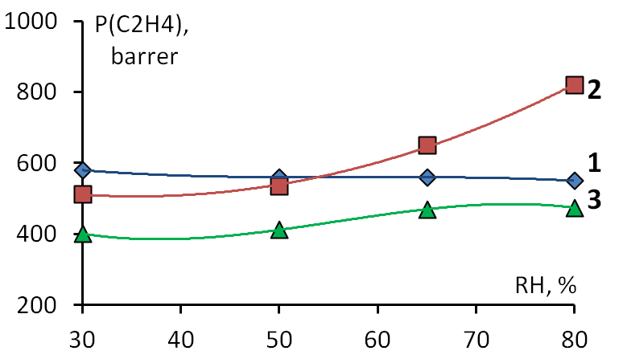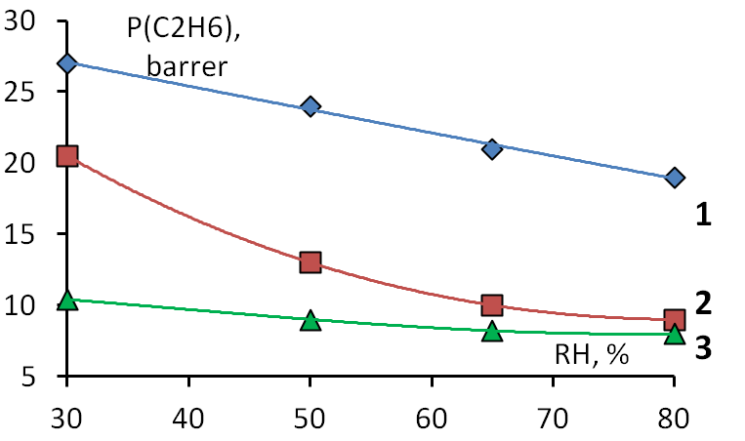
Figure 1. The dependence of the permeability coefficients of ethylene on humidity for the membranes with PS content of 26 % (1); 43 % (2); 55 % (3). | Figure 2. The dependence of the permeability coefficients of ethane on humidity for the membranes with PS content of 26 % (1); 43 % (2); 55 % (3).

The separation factor for this sample is nearly independent of the humidity of the gas mixture, increasing only slightly by lowering the permeability ethane (Fig. 3).
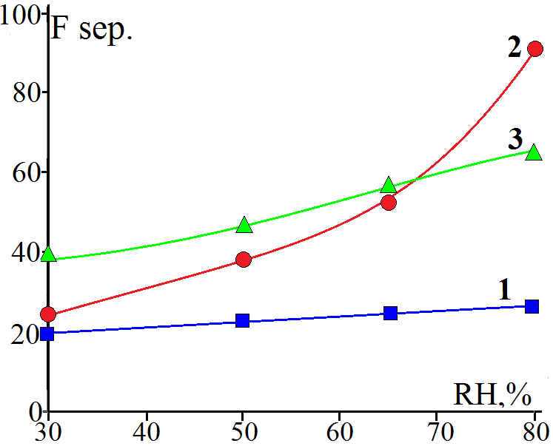  Figure 3. The dependence of ethylene/ separation factor on humidity for the membranes with PS content of 26 % (1); 43 % (2); 55 % (3). | With increasing in PS content the percolation threshold is reached, and ethylene transfer occurs mainly through a system of pores and channels of the membrane. Another factor is dominated with increase in humidity. The permeability of ethylene increases owing to increased mobility of its complex with a proton with an increase in moisture content and pore volume (Fig. 1). However, for the highest grafting degree, when a large number of pure water exists in the pore center, permeability of ethylene grows significantly slower (Fig. 1). In this regard, a clear increase in the ethane separation factor (Fig. 3) is observed, the most marked for the sample with PS contant equal to 43%.
A study of the effect of the initial ethane and ethylene mixture composition on the transport properties of membranes with different degrees of grafting showed that the ethylene permeability coefficient decreases with an increase in ethylene partial pressure from 10*10² Pa to 60*10² Pa (Fig. 4). A decrease in the separation coefficient of ethylene is also observed (Fig. 5). Apparently, this is explained by the decrease of the ethylene permeability coefficient with increasing its concentration in the initial ethylene / ethane mixture and is related to the mechanism of its membrane transport [2]. The transfer of gases occurs due to the Langmuir sorption (the so-called double sorption mechanism), in which the penetrant is selectively sorbed by the carrier. Such a carrier, as noted above, is a proton that forms complexes with C₂H₄. Due to the relatively low mobility of complexes of proton with ethylene, the concentration of protons appears to be a limiting factor in their transfer through membranes, which, with an increase in the initial partial pressure of ethylene, leads to a decrease in its permeability coefficient.

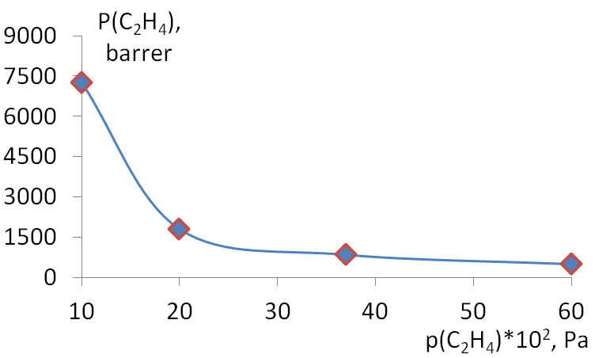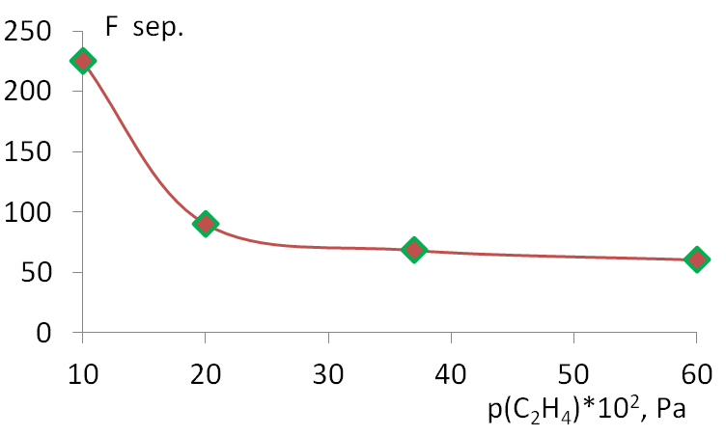
Figure 4. The dependence of the permeability coefficients of ethylene on its partial pressure of the initial mixture for the membrane with PS content of 55 %, С₂Н₄:С₂Н₆ =6:94 v./v., humidity – 80%. | Figure 5. The dependence of the ethylene/ ethane separation factor from the partial pressure of ethylene in the initial mixture for the membrane with PS content of 55 %, С₂Н₄:С₂Н₆ =6:94 v./v., humidity – 80%.

Thus, these results confirm the assumption about the prospect of using of membranes of facilitated transport, based on PE grafted with PSS in hydrogen form, for the separation of ethylene and ethane mixtures.
Conclusions
Effect of "facilitated" ethylene transfer through the ion exchange membranes in the hydrogen form described at the first time. This can permit to optimize the process of a ethane and ethylene mixture separating.
The most selective ethylene extraction was carried out with the use of ion exchange membrane in the hydrogen form at relative humidity of mixture equal to 80% with the ethylene separation factor equal to 97.

References
1.Safronova E.Yu., Golubenko D.V., Shevlyakova N.V., D'yakova M.G., Tverskoi V.A., Dammak L., Grande D., Yaroslavtsev A.B./ New cation exchange membranes based on cross-linked sulfonated polystyrene and polyethylene for power generation systems./ J. Membrane Sci. 2016, V. 515, p. 196–203.
2. Zhilyaeva N.A., Mironova E.Yu., Ermilova M.M., Orekhova N.V., Bondarenko G.N., Dyakova M.G., Shevlyakova N.V., Tverskoy V.A., Yaroslavtsev A.B.//Petroleum chem. 2016. V. 56. P.1034-1041.

