Transport properties of asymmetryc and composite membranes based on chitosan copolymers with vinyl monomers
¹Kseniia Otvagina, ²Alla Mochalova, ¹Tatyana Sazanova, ¹Artem Atlaskin, ¹Ilya Vorotyntsev.
¹Nizhny Novgorod State Technical University n.a. R.E. Alekseev, 603950, , Nizhny Novgorod, 24 Minina str., Russia, e-mail: k.v.otvagina@gmail.com
²Lobachevsky State University of Nizhny Novgorod, 603950, Nizhny Novgorod, 23 Gagarin av., Russia
Introduction
In the past decades, membrane separation of contaminations and impurities from gases and liquids has been attracting a rising interest due to their advantages over conventional separation processes such as reduced environmental impact, lower energy consumption, and operating costs. A variety of polymeric materials and the possibility to modify them enables the design of a membrane with desired separation performance for a particular task. Among polymers for “green” membrane design, amino polysaccharide chitosan (CS) stands out due to remarkable thermal stability and biodegradability. Chitosan is derived from chitin, an abundant natural polymer constituting the crustacean’s exoskeleton. Due to the presence of the amino group in its repeating unit, it shows an efficient binding of acid gases, such as carbon dioxide, negatively charged dispersions and microbial contaminations. High crystallinity of CS causes low physical-mechanical properties and low permeability through pure CS films. Previously it was shown that mechanical stability and permeability of gases through the CS membrane could be improved by obtaining copolymers with vinyl monomers and ionic liquid doping [1]. However, operational properties of the material also depend on the membrane morphology and the method of production. There are different approaches for the membrane production according to desirable morphology: sintering, stretching, track-etching, phase inversion and coating. Most commercially available membranes are produced by phase inversion technique. This is a very versatile technique allowing all kinds of morphology to be obtained. Phase inversion is well studied for acetate cellulose, polysulfones, polyamides and etc.

The scope of the present work is focused on preparation and characterization of asimmericand composite membranes based on CS copolymers with poly(acrylonitrile) (PAN) and poly(styrene).
Experiments
CS copolymers with acrylonitrile (CS-PAN) and styrene (CS-PS) were obtained according to the previously published technique [2]. Composite membranes were prepared by copolymer solution casting onto porous support (polysulfonamide) followed by solvent evaporation. Asymmetric membranes of pure CS and CS copolymers were obtained by phase inversion technique. The 2% solution of sodium hydroxide in water was used as a nonsolvent. In order to control the formation of asymmetric and composite membranes microscopy method were used. Scanning electron microscopy (SEM) micrographs of the surfaces fractured perpendicular to the membrane plane (cross-section) were obtained with a Zeiss Merlin SEM (Carl Zeiss, Germany) at 10 kV. Atomic force microscopy was conducted using SPM-9700 (Shimadzu, Japan) with the silicon vibration cantilevers Pointprobe FMR-20 (Nano World Innovative Technologies, Switzerland) with a typical tip curvature radius of no greater than 8 nm with 15 μm length of the tip. Measurements were all carried out under ambient conditions using the tapping mode of imaging. The arithmetic average roughness height (Ra) and the mean roughness depth (Rz) were obtained by a program in the AFM image processing toolbox SPM Online, Version 4.02, (Shimadzu, Japan). Transport properties of the membranes were investigated in pervaporation and gas separation. Pervaporation was tested on water – tetrahydrofuran (THF) mixture in azeotropic composition (water content = 6%, THF content = 94%) using a laboratory cell with an effective membrane area of 9,6 cm2 at abundant temperature. Permeate composition was identified using a refractometry. The fluxes, J (kg/m2 h), were determined as an amount of liquid transported through the unit of the membrane area per hour. The single gas permeability coefficients of nitrogen, carbon dioxide, and methane through the obtained membranes were measured. Ideal selectivity (α) for pairs of gases was calculated as a ratio of its permeability coefficients.
Results and Discussion
SEM cross-sections micrographs of the obtained composite membranes allowed confirming the excellent adhesion of the selective top layer onto the porous support (polysulfonamide) with the thickness of 750 and 1200 nm for CS-PAN and CS-PS, correspondingly. SEM micrographs are presented at figure 1.

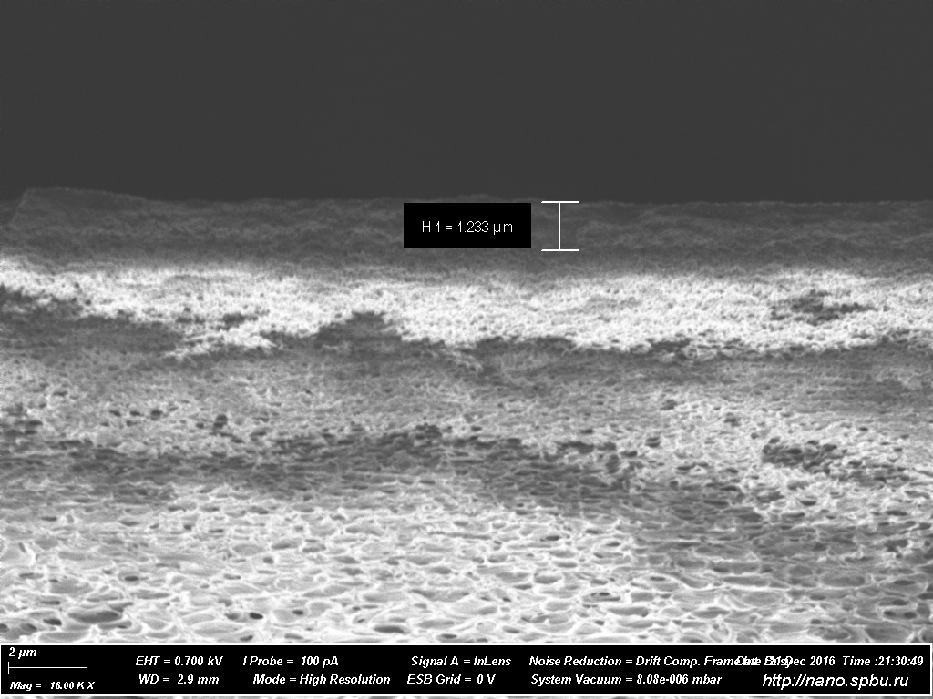 | 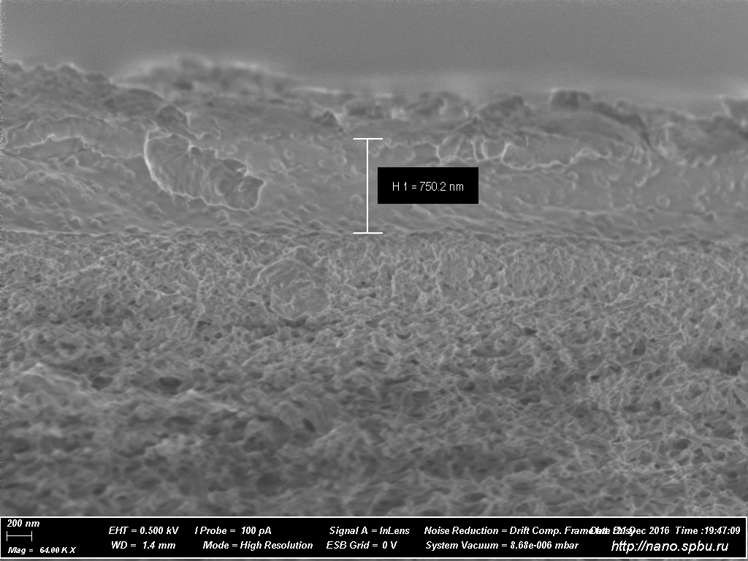
a | b

Figure 1. The SEM micrographs of composite membranes:
a) CS-PS top layer; b) CS-PAN top layer

It demonstrated that copolymers formed continuous nonporous coat without any defects. AFM images reveals nodular microstructure of the surface, which is typical for homogeneous films based on obtained copolymers. The roughness parameters Ra and the Rz increased 2-fold in comparison to the preliminary surface of the support. Transport properties of the developed membranes was tested during separation of azeotropic water – tetrahydrofuran (THF) mixture (water content = 6%, THF content = 94%) by pervaporation. Pervaporation data is presented in table 1.

Table 1. Pervaporation data.

Membrane selective layer | Water content in tested binary  mixture, wt.% | Water content in permeate, wt. % | J, (kg/m² h)
CS-PAN | 6 | 94,8 | 0,145
CA-PS | 6 | 6 | 0,143

Prepared membranes were tested for gas permeation using N₂, CH₄ and CO₂ as test gases. The values of permeability coefficients are presented in table 2.
New CS based membranes were prepared by phase inversion method using “wet” and “dry” technique. The AFM of the materials based on pure CS shows a difference in the surface topography of the two sides of the membrane "to the substrate" or "to the air".

Table 2. Pervaporation data.

Gas | Permeability coefficient, Barrer
Gas | support | Support + CS-PS | Support + CS-PAN
He | 1640,13 | 266,52 | 55,01
N₂ | 786,66 | 124,30 | 21,75
Ar | 625,36 | 113,10 | 18,45
H₂ | 2115,02 | 352,10 | 69,14
CH₄ | 943,65 | 160,70 | 42,04
CO₂ | 683,75 | 110,02 | 29,00
N₂O | 627,50 | 100,53 | 25,22
NH₃ | 79714,06 | 172,70 | 23,67
H₂S | 974,96 | 117,62 | 42,17

This is confirmed by the difference in the parameters of the roughness Ra and Rz for both sides more than twice. On the surface of membranes, depressions are visualized, which may be dead-end pores of complex configuration. The results of SEM confirm the formation of an asymmetric structure of membranes obtained by the "wet" method, with the formation of a denser and more friable layers of different thicknesses. In the case of membranes obtained by the "dry" method, the formation of an asymmetric structure was not confirmed.
There we can conclude that obtained membrane despite low separation ability might be useful for special applications, and also the approach shown there might be distribute for wide range of CS copolymers.

References
- Otvagina, Ksenia V., et al. Preparation and Characterization of Facilitated Transport Membranes Composed of Chitosan-Styrene and Chitosan-Acrylonitrile Copolymers Modified by Methylimidazolium Based Ionic Liquids for CO₂ Separation from CH₄ and N₂//Membranes 6.2. 2016. 31.

