STUDY OF THE PROTON TRANSFER PROCESSES IN NON-AQUEOUS SOLUTIONS OF BRØNSTED ACID
Irina Fedorova and Lyubov Safonova
G. A. Krestov Institute of Solution Chemistry of Russian Academy of Sciences, Ivanovo, Russia,
E-mail: fiv@isc-ras.ru
Introduction
Lately, phosphorus acids with the formula H₃PO_{n+1} for n=1÷3 are considered suitable candidates as ionomers because of their efficient proton transport properties. They are amphoteric, i.e. can act as both proton acceptors (through O(=P)) and proton donors (sharing hydroxyl protons) and have a relatively high dielectric constant. The combination of these properties leads to a high degree of auto dissociation which favors the formation of a hydrogen-bonding network. This work is a continuation of our previous computational studies relating to the processes of proton transfer in the H-bonded complexes of phosphoric and phosphonic acids (H₃PO₄ and H₃PO₃) with DMF [1, 2]. To extend our study, in the present work, we investigate the last member of this family, phosphinic acid (H₃PO₂), also called hypophosphorous acid. In addition, structural data for the H₃PO₂–DMF complex were obtained for the first time. Since proton transfer occurs mostly in solution, the effects of solvation on the potential energy surface (PES) for proton transfer were studied.
Computational methods
Geometry optimizations of the solvated complexes were carried out with the B3LYP/6-31++G(d,p) level of theory as implemented in the Gaussian 09 program. All calculations in solvent were performed using the CPCM approach to model the condensed phase. The minimum-energy states of the complexes were confirmed by calculating the harmonic frequencies.
The potential energy profiles for proton transfer from phosphinic acid to proton acceptor atoms in H₃PO₂ and DMF molecules (oxygen atoms in P=O and C=O groups), respectively, as a function of the proton coordinate (δ=r₁–r₂, where r₁ and r₂ are the distances from hydrogen atom to oxygen atoms in O₁–Н…O₂ fragment) were evaluated using the potential energy surface (PES) scan method. A hydrogen atom was transferred between oxygen atoms in a hydrogen bond with an increment of 0.05 Å, and the transition state at each point of the scan was optimized under different conditions: (i) fixed O…O distance for the H-bond, where the acidic proton is transferred only and (ii) relaxed O…O distance. The former situation is associated with the significant rates of proton transfer, especially in the systems with very strong H-bonds wherein the structural rearrangement (H-bond breaking and forming) is rate-limiting step of this process [3].
The energy values (ΔE) for proton transfer in considered complexes were calculated from the difference of the energies of the partially optimized geometries with R_{i} and δ_{i} parameters and the fully optimized structure (Е (R, δ)).
Results and Discussion
Figure 1 shows the most stable (H₃PO₂)₂ and H₃PO₂–DMF structures in DMF environment modeled by the CPCM.
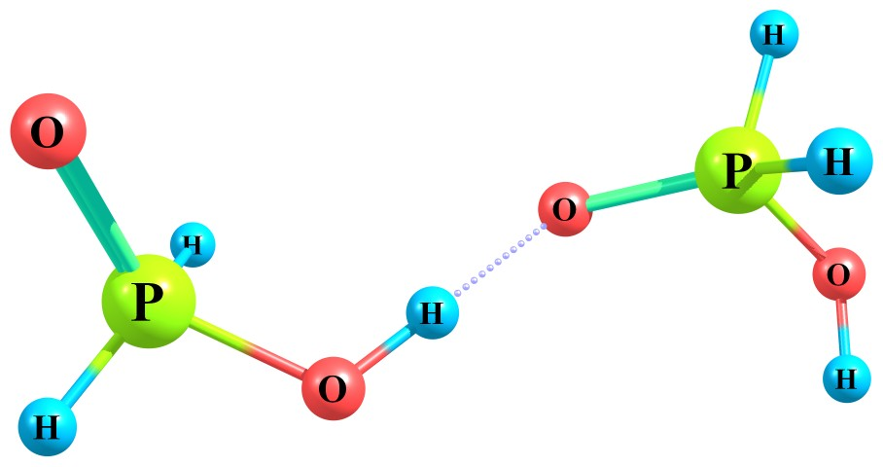(a) | 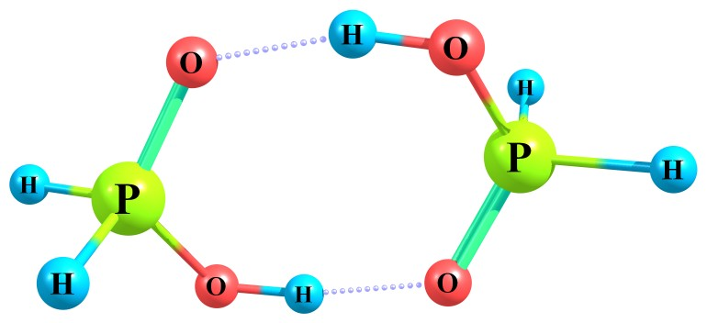(b) | 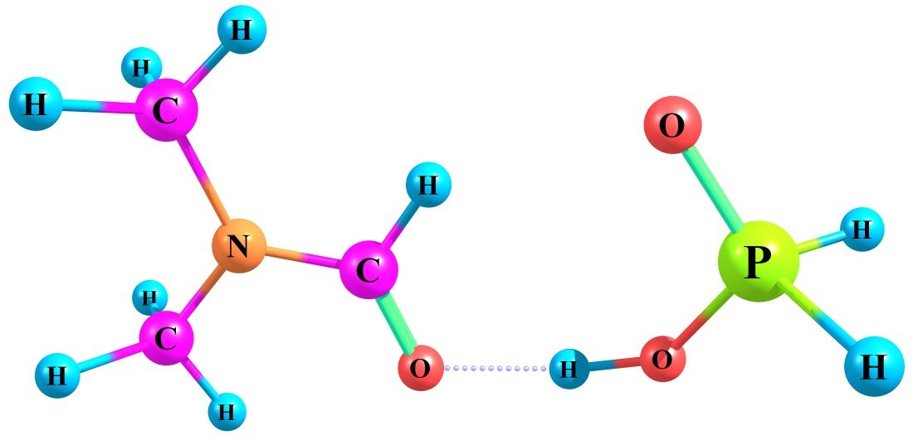(c)
Figure 1. Optimized structures of two different kinds of H₃PO₂ dimers (a, b) and H₃PO₂–DMF complex (c) under CPCM solvent conditions
In the structure 1a, the H₃PO₂ dimer contains only one hydrogen bond with O…O distance of 2.604 Å and H-bond angle of 177.6°. Configuration 1b is a clear ring-like structure where the two H₃PO₂ molecules are held together by two H-bonds. The O…O distance of 2.602 Å and respective angle of 172.8° in the cyclic (H₃PO₂)₂ are equal for both hydrogen bonds. The calculated values of the binding energies of acid monomers in dimers show that the formation of both acid dimers in DMF environment is an energetically favorable process. The binding energy (E_{bind}) of the linear H₃PO₂ dimer was calculated to be -35.52 kJ/mol, while the E_{bind} value of cyclic configuration is -63.16 kJ/mol (31.58 kJ/mol per one H-bond).
The hydrogen bond between H₃PO₂ and DMF molecules in the complex is quasisymmetric, i.e. the hydrogen atom is closer to the oxygen atom in the O-H group of acid than to the oxygen atom of the C=O group of DMF. The O…O distance in the H₃PO₂–DMF is 2.563 Å, indicating a much stronger hydrogen bond compared to the H₃PO₂ dimers. The supplement angle value (178.3°) shows an insignificant deviation from linearity of the three atoms. For H₃PO₂–DMF the E_{bind} value is -51.98 kJ/mol.
Proton transfer in the fully relaxed structures of H-bonded complexes. As can be seen in Figure 2, the PES for proton transfer in the cyclic H₃PO₂ dimer has symmetric energy profile with respect to the center of the hydrogen bond (δ ∼ 0). In this case, the proton transfer along one of the H-bonds promotes the back transfer of the other proton in the second hydrogen bond (the double proton transfer); and the structure transforms itself into the initial configurations.
For the linear H₃PO₂ dimer and H₃PO₂–DMF the potential curves show similar shapes. The PES for each of these complexes has single minimum. The transferred proton is localized near the oxygen atom in the hydroxyl group of phosphinic acid. The energy of these systems rapidly increases with the proton transfer. Although these complexes have strong H-bonds, the proton transfer is not observed either.
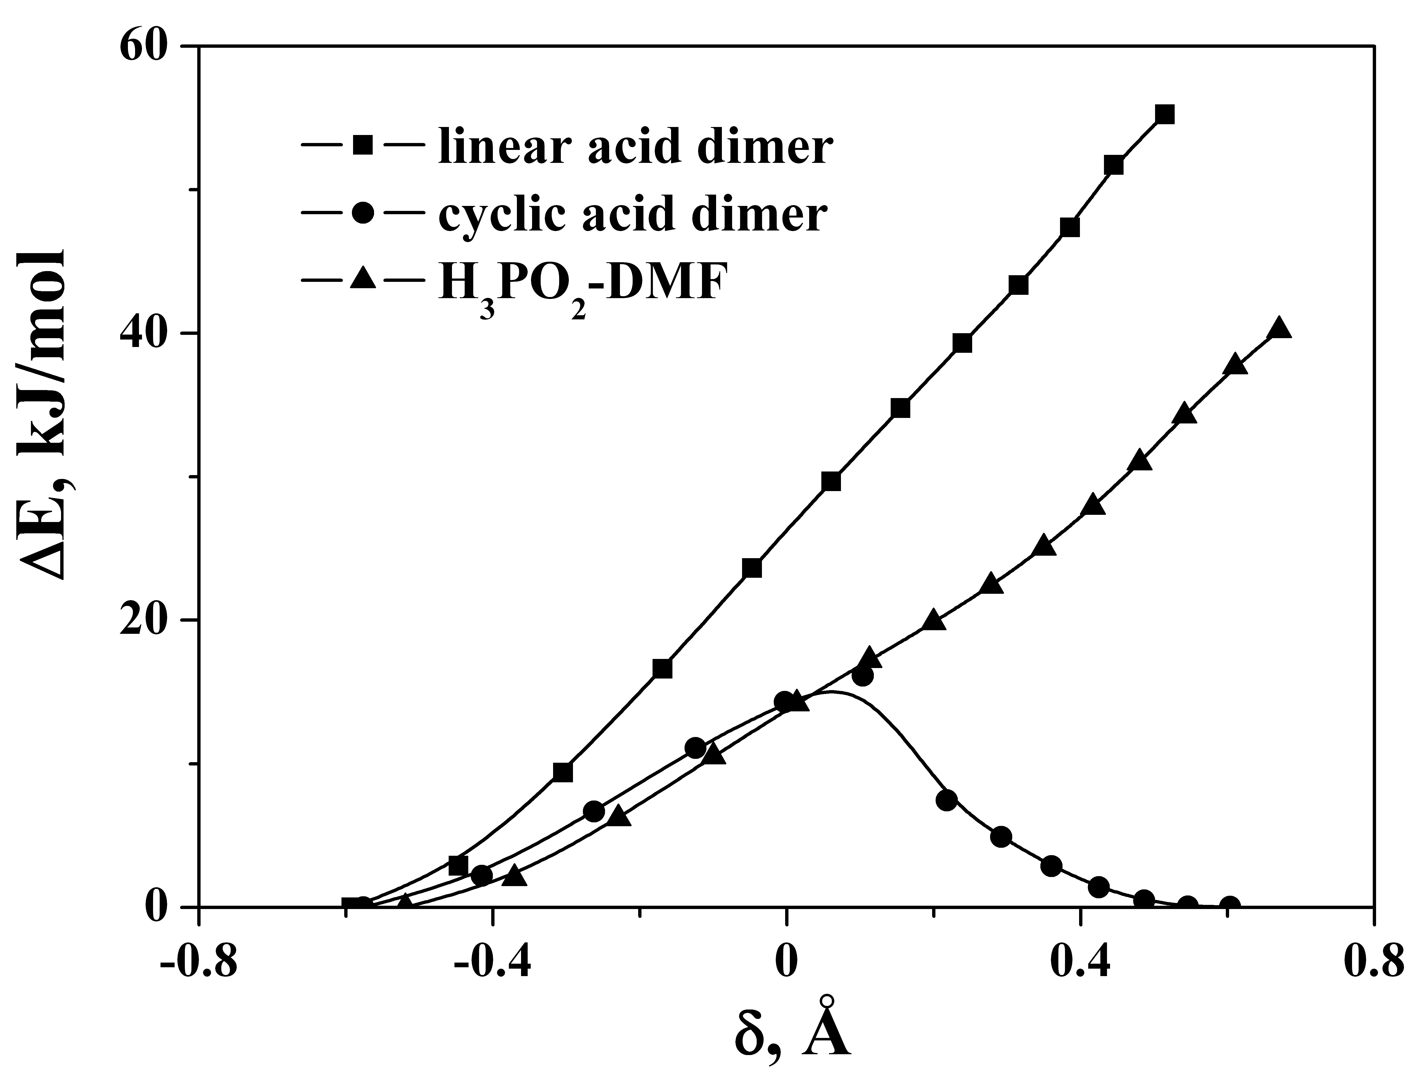
Figure 2. Potential energy profiles for proton transfer in the solvated H₃PO₂ dimers and H₃PO₂–DMF complex. The curves for each case are assigned in the legend
Proton transfer in H-bonded complexes at fixed O…O distances (r_{OO}). The energy curves for proton transfer in the H₃PO₂–DMF are plotted in Figure 3. Similar results are observed for linear structure of the H₃PO₂ dimer. The PES has a single distinct minimum for sufficiently small O…O distances whereas a double-well curve appears along the proton transfer coordinates at r_{OO}>2.5 Å. In the latter cases, the proton can pass through the energy barrier, if this process will take place. This suggests that a hydrogen atom will be bonded to either the oxygen of acid or the DMF oxygen atom, but will not stay in the transition state. With increasing intermolecular O…O distance the energy barrier increases. It is worth noting that the proton transfer process in the solvated complex of H₃PO₂ with DMF at fixed distances is more favored than the ones between acid molecules themselves. For comparison, the energy barrier heights for, e.g., r_{OO}=2.7 Å are 68.59 and 51.97 kJ/mol for the linear H₃PO₄ dimer and H₃PO₂–DMF, respectively.

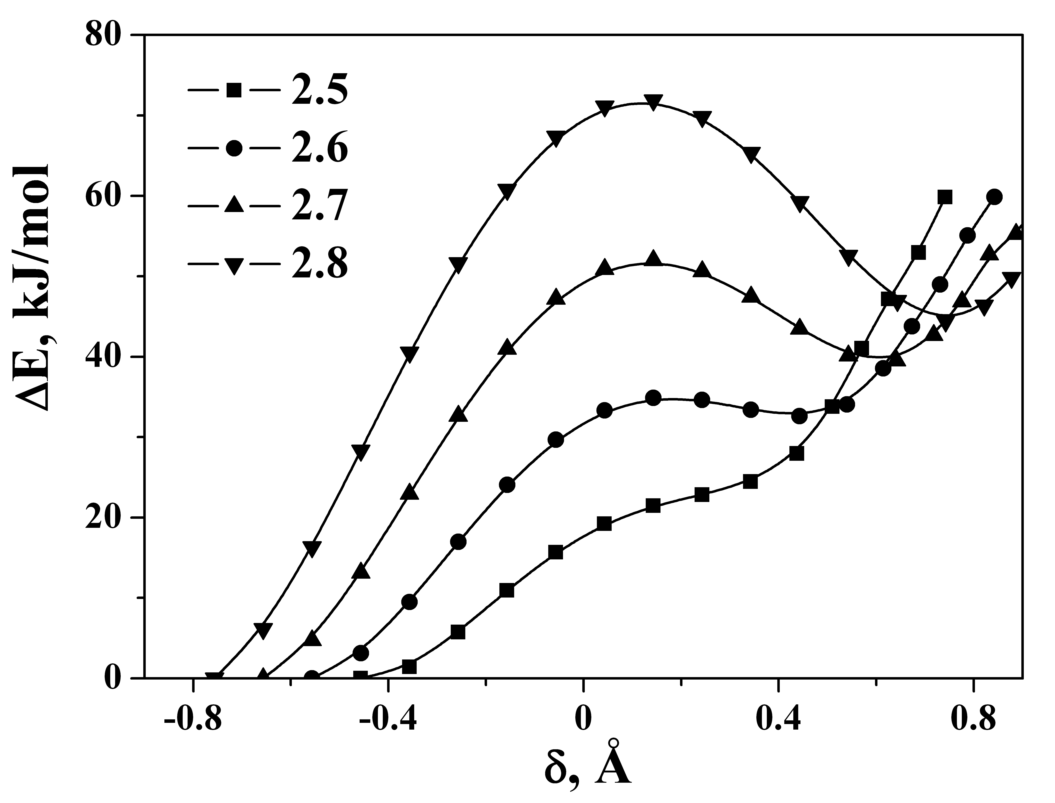
Figure 3. Potential energy profiles for proton transfer in the solvated H₃PO₂–DMF complex at various fixed O…O distances. The curves for each distance (Å) are assigned in the legend
In order to compare the three acids of phosphorus (phosphoric, phosphonic and phosphinic acids), the energy profiles for proton transfer in acid–DMF complexes at r_{OO}=2.7 Å are collected together in Figure 4. All curves show qualitatively similar shapes when passing from H₃PO₂ to H₃PO₃ and Н₃РО₄. The PES for each of the complexes has a double-well form (but not symmetric). The height of the energy barrier for proton transfer in complexes of these acids with DMF becomes lower with increasing number of OH groups of acid.
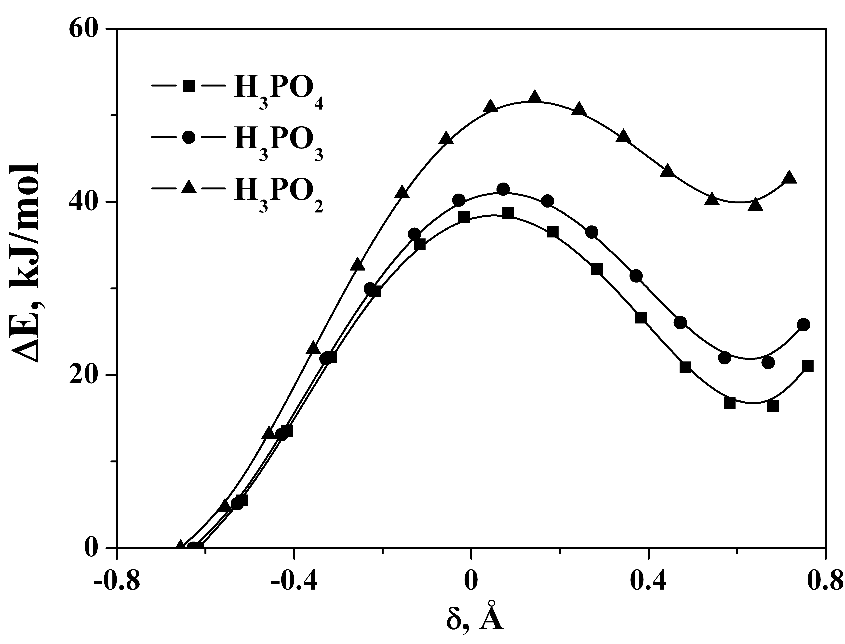
Figure 4. Comparison of the potential energy curves for proton transfer in the solvated complexes of phosphorus acids with DMF at r_{OO}=2.7 Å. The curves for each case are assigned in the legend
References
1. Fedorova I. V., Khatuntseva E. A., Krest'yaninov M. A., Safonova L. P. C-PCM based calculation of energy profiles for proton transfer in phosphorus-containing acid–N,N-dimethylformamide complexes // Russ. J. Phys. Chem. A. 2016. V. 90. № 2. P. 293-299.
2. Fedorova I. V., Krestyaninov M. A., Kiselev M. G., Safonova L. P. Solvent effect on proton transfer in the complexes of N,N-dimethylformamide with sulfuric and phosphoric acid: A DFT investigation // J. Mol. Struct. 2016. V. 1106. P. 424-429.
3. Kreuer K. D. On the complexity of proton conduction phenomena // Solid State Ionics. 2000. V. 136-137. P. 149-160.
This work was partially financially supported by the Russian Foundation for Basic Research (Project No. 15-43-03088).

